**Realtime-Systems Homework Attestation**

*Name: Emre Dogan*

*Matrikel Nr.: 1136685*

1. What can you interpret out of the time-path diagram?
2. Which station has the longest waiting time?
3. Any idea why? Which line section is the fastest one? Any idea why?

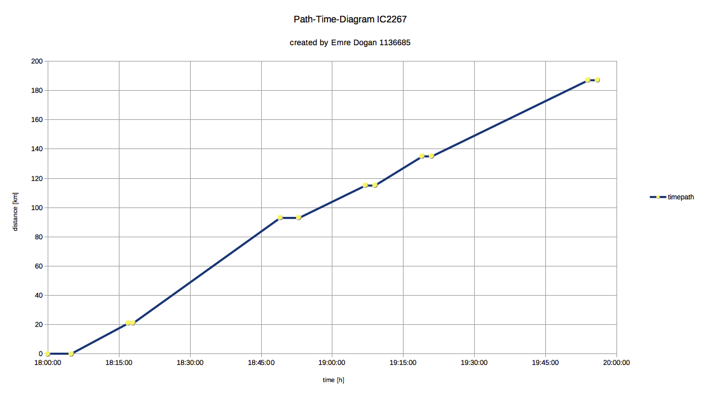

1. To the main Stations Stuttgart and Ulm is the path longer than to other stations. That means the train literally rides through small cities and than stops at big main stations.
2. Stuttgart Hbf has the longest waiting time, most probably because there, many people leave and enter the train and this costs some time. Or trains are waiting each other so they can start.
3. The line path from Bruchsal to Stuttgart is the fastest one. Probably its because the distance is highest and that’s why the train than drives faster than between small cities/villages.

Columns:

|  |  |  |
| --- | --- | --- |
|  | 18:00:00 | 0 |
| Karlsruhe | 18:05:00 | 0 |
| Bruchsal | 18:17:00 | 21 |
| Bruchsal | 18:18:00 | 21 |
| Stuttgart Hbf | 18:49:00 | 93 |
| Stuttgart Hbf | 18:53:00 | 93 |
| Plochingen | 19:07:00 | 115 |
| Plochingen | 19:09:00 | 115 |
| Göppingen | 19:19:00 | 135 |
| Göppingen | 19:21:00 | 135 |
| Ulm Hbf | 19:54:00 | 187 |
| Ulm Hbf | 19:56:00 | 187 |